Organizing Liberal U.S. Jews
A new way forward for countering structural racism and white nationalism

Amelia Mae Paradise
May 6, 2019
Critical Review
Sociology 530: Intersectionality
University of New Mexico

Abstract
The purpose of this study is to apply intersectionality as an analytic tool to explore the potential for and the problematics of anti-racism movement building amongst the U.S. liberal Jewish community in 2019. This paper focuses on scholarship addressing two primary arenas relating to this inquiry: 1. What are the iterative and commutative processes of narration that construct the social fabric of “groupness” (collective selfhood) for liberal Jews and how do these processes impact anti-racism movement building? 2. How does the social construction of whiteness in the liberal Jewish community in the U.S. inform engagement with anti-racism activism? Though we see ourselves as a socially progressive and egalitarian group, we are also a people who inhabit the paradoxical and concurrently fully integrated contradictory identifiers as both persecuted/more in danger than others as well as chosen/better than others. I posit that this unexamined concurrence directly limits anti-oppression organizing focused on dismantling systemic racial oppression and countering the mainstreaming of the white nationalist social movement. For Jewish social justice movement building to be effective today we must rigorously examine our Jewish social location in order to significantly shift civic engagement with constructive social transformation and guarding against the infliction of further harm as both targets of and complicit participants in U.S. structural racism.

  - “When you are engaging in intersectional analysis you are engaging in insurgent scholarship, insurgent knowledge production. And there will be repercussions.” – Nancy Lopez
On October 27th 2018, I learned of the shooting at The Tree of Life Synagogue in Pittsburgh. I wasn’t shocked; mass shootings simply don’t surprise me anymore. But, I didn’t know what to feel. I’d never internalized the imminent threat component of the U.S. Jewish sense of self that seemed more common to my parents’ generation, and I didn’t know people in Pittsburgh to feel the personal emotional ripplings of connectedness. And I certainly didn’t know how to understand this overt expression of antisemitism, in the context of my political analysis of the United States, which is deeply rooted in a study of capitalism, racism, and sexism but never situated antisemitism.
On April 27th, 2019, 6 months to the day from the Pittsburgh massacre, I learned of the shooting at the Chabad of Poway in San Diego. I don’t remember if I was shocked about the shooting itself. Acceptance or disbelief of the event were immediately suffused with strong feelings. I was completely overcome with an emotional and visceral response which included sadness and tears, loneliness and withdrawing, and a vivid upwelling of can only been known as generational trauma: its pre-Nazi Germany and I have to choose to stay or leave. This moment is life or death. This time, I knew what to feel.
What had changed? In the last six months, I’ve been deep in the work of founding the Jewish Bridge Project of New Mexico with a mission to engage the central New Mexico Jewish community in antiracism consciousness shift. The aim of this endeavor is to increase safety, thriving, vitality, and positive life outcomes for People of Color in New Mexico and all people vulnerable to white supremacy. The approach prioritizes teaching historical context, honoring personal experience and healing justice practices, defining common terms within the Jewish justice ethic, and exploring the interplay of antisemitism, racism, and white nationalism both within Jewish institutions and in the U.S. at large. In conjunction with development of Jewish Bridge Project of New Mexico programs, I’ve connected actively with two different national Jewish social justice organizations: Tzedek Lab and Bend the Arc. Both organizations have detailed values-based organizing tenets.
Tzedek Lab is a national multi-racial network of Jewish political education trainers, organizers, and spiritual leaders established to build collective competency to better politicize, transform, and inspire the Jewish community into collective action against racism, antisemitism, and white supremacy with 5 organizing tenants. 1: Our work is strengthened through solidarity, not isolation. “We believe our liberation is bound up with each other, so our work can’t be for others; it has to be in partnership with others.” 2. We respect and honor each other. We trust one another, our inherent worth, and our wisdom. “We take seriously the wisdom that our unique stories and experiences give us and we believe that we and each other are inherently worthy of trust.” 3. We act boldly. “We show up, unapologetically, knowing our inherent worth and acting in/out this truth.” 4. To lead is to listen. “We believe that our visionary work can remain relevant if we are committed to listening to our partners.” 5. We can take care of us. That is ok to do. “We believe the work of liberation includes caring for and nurturing ourselves.”
Bend the Arc is a movement of progressive Jews across the country who are fighting for justice and equality for all. Guided by 5 core values and long-term vision, Bend the Arc is in deep partnership with a multiracial movement seeking to transform our country to be inclusive, equitable, and supportive of the dignity of every person across race, class, gender, age, ability, sexual orientation, and faith. The core values are: 1. Moral courage: “We know the fight for justice and equality will not be easy or simple and requires us to take risks and act boldly. We act with integrity and we seek wisdom from our Jewish and social movement traditions to guide us.” 2. Partnership: “We recognize the power and importance of working in community with others. Through partnership and collaboration, we are able to leverage the unique strengths of our partners and allies and learn from the broader movement for justice.” 3. Impact & Effectiveness: “We choose goals and campaigns that we believe will be effective in making lasting and systemic change that will impact people’s lives. We are careful stewards of our resources and deploy them strategically and with purpose.” 4. Dignity & Equality: “We honor and protect the dignity and inherent right of all people to live in freedom and security, with access to opportunity. We treat each person with respect, honor differences, and pursue justice for all people.” 5. Resilience: “We are in this work for the long haul. We persevere through challenges, find creative solutions to problems, and we create loving, meaningful, joyful community to help sustain us.”
What changed for me between October 27, 2018 and April 27, 2019 was direct exposure to radical and current intentional social movement building based on values, narratives, and analysis within which I could locate myself and find energizing connectivity within a system of shared group meaning. As a 44 year old white Jewish dyke woman born upper-middle class in New Mexico, I have found a movement home.
The policy topic I am focusing on is the need to prioritize anti-racism education within liberal Jewish institutions in Central New Mexico. The social inequality this topic addresses is the systemic and institutional oppression of People of Color in the United States, and all people targeted by white supremacy. I believe this topic is important for two primary reasons. First, in an effort to acknowledge and dismantle the racism Jews of Color face within Jewish communities, adult education must be prioritized for racially privileged Jews to understand their racialized social location of power within the Jewish community. Second, in an effort to harness the existing and widespread dedication to the Jewish social justice ethic of Tikkun Olam (Repairing the World) the Jewish community at large must understand the racialized institutions and structures of oppression in the United Sates. The current justice ethic in the mainstream liberal Jewish movements is too-often based in a humanist color-blind approach and fraught with confusion about Jewish precariousness in the face of antisemitism. I believe a full understanding of at least three intersectional concepts: 1. Collins’ Matrix of Domination, 2. Frankenburg’s Racial Social Geography, and 3. Lopéz’s Intersecting Social Locations and Lived Experience, is necessary to effective Jewish antiracism action. Collins’ 2009 Matrix of Domination is a framework for understanding both a particular arrangement of intersecting systems of oppression (race, class, gender, sexuality, citizenship status, ethnicity, and age) and a particular organization of the domains of power of the oppressions (structural, disciplinary, hegemonic, and interpersonal.) Frakenburg’s Racial Social Geography refers to the “racial and ethnic mapping of environments in physical and social terms and enables also the beginning of an understanding of the conceptual mapping of self and other operating in white women’s lives.” (Frankenburg, 44) Her concept encourages the race cognizance of confronting and challenging systems of oppression. Finally, Lopéz’s visual map (see below) for understanding Intersecting Social Locations and Lived Experience provides a tool to understand both one’s self-perception as well as one’s social location in power-based systems simultaneously, which allows for full humanizing of the experience of waking up to oppressive systemic analysis.
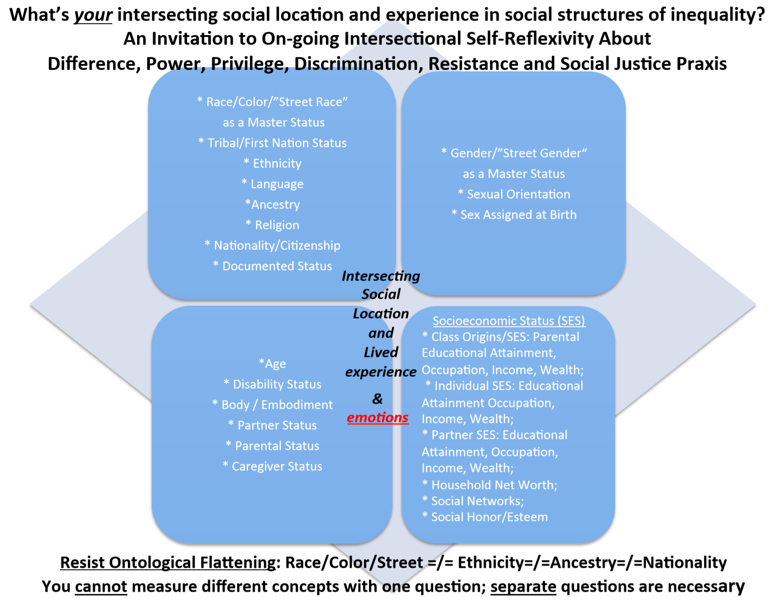
Nancy Lopéz’s Tool for Intersectional Self Reflexivity
With these intersectional tools, liberal Jewish movement work can better understand personal and group social location within systems of oppression and transform the current Jewish action ethos of charity and volunteerism into a more effective action towards equity with the ideology that less racism, brutality and oppression benefits all members of a society.
The stakeholders/decision makers within the intuitions are: the Rabbi & Cantor (for the religious institutions) the Director of Education, the Social Justice organizer (if there is one), The Administrative Director, The Education Director, and the members of the Board of Directors. There are also ancillary community thought-leaders and gate-keepers, such as the Editor of the Jewish Newspaper, the Board of Directors at the Jewish Federation, and the Executive Director of the Jewish Community Center. The targeted audience of my policy brief will not predominantly be academicians. They will be Jewish professionals with long careers within mainstream Jewish institutions. I anticipate they will be majority white heterosexuals from somewhat varied class backgrounds, represent a national geographic range, and have little formal exposure to critical race analysis or intersectionality. They will see themselves as muchly progressive on social issues, and be mostly supporters of the nation-state of Israel. The final point is relevant, in that I perceive there to be some internal contradictions of “progressive” and that these self-perceptions will not necessarily map to my understanding of social progressiveness. I will need to account for this attentively in the construction of my final policy brief.
This critical review consists of five articles, grouped into 2 sections. In the first section, Narratives & Collective Selfhood in Movement Building I discuss two peer-reviewed articles, one qualitative sociological study and one anthropological conceptual study. In the second section, Social Construction of Whiteness in liberal Judaism in the U.S. I discuss three peer reviewed articles comprised of two qualitative sociological studies and one interdisciplinary conceptual study. I end with a discussion of policy options including the current practices and projected outcomes and two policy options and their projected outcomes, including one that engages intersectionality in conversation with a sixth peer-reviewed article, an interdisciplinary intersectional conceptual study which provides the final framework for the policy recommendation. Throughout this critical review, I asses for the presence or absence of Leslie McCall’s three approaches to understanding the intersectional methods of categorizing inequality in social life. The first approach, anticategrical complexity, is a primarily philosophical approach which concerns itself with the deconstructing of the analytical categories used to understand inequality. The second approach, intercategorical complexity, though like the first category, takes a critical stance toward categories, and like the third, acknowledges stable and durable in-group categories, it is primarily concerned with comparing complexity across social locations. The third approach, intracategorical complexity, is concerned with documenting and assessing inequality within and among a single social group. (McCall, 1773-1774)

Narratives & Collective Selfhood in Movement Building

  - “It occurs to me that much organizational grief could be avoided if people understood that partnership in misery does not necessarily provide for partnership for change: When we get the monsters off our backs all of us may want to run in very different directions.” June Jordan

Conflicting Narratives of Collective Selfhood in Stigmatized Groups
“By recognizing the multiple narratives of collective selfhood that emerge from identity politics, we can better understand the sometimes-vitriolic inﬁghting within groups that have been systematically stigmatized and disadvantaged … The time has come to investigate the different ways people practically envision what it means to be an “I” and part of a “we” and what those deﬁnitions imply for social change …When a movement, in the broadest sense of the term, fails to negotiate these tensions to all members’ satisfaction, some members may respond by shifting to an alternative mode of organizing, with a narrative of collective selfhood they see as more accurately reﬂecting their experiences and goals.” (Moon, 1337)

In her 2012 empirical sociological study Who Am I and Who Are We? Conflicting Narratives of Collective Selfhood in Stigmatized Groups, Dawne Moon addresses the main research question that though identity politics rise from social conditions of systematic stigmatization and structural disadvantage, sharing a social location does not guarantee same self-identification and collective-identification. According to Moon, identity politics gives rise to several alternative ways of conceptualizing the collective self. Using ethnographic material gathered on American Jews’ understandings of antisemitism and its relationship to contemporary politics, her article “inductively discerns four alternative models of collective selfhood (embattled, relating, political, and redeemed) that correspond to four alternative narratives of identity politics (reiﬁed identity, humanistic dialogue, critical solidarity, and evangelism).” (Moon, 1336)
Utilizing qualitative, semi-structured interviews and observational data, Moon interviewed 59 American Jews (32 in individual interviews and 27 distributed across two focus groups.) Specifically seeking generational representation, including primary memories of World War II and the Nazi Holocaust, two focus groups were conducted in a Jewish retirement and nursing home. Interview subjects ranged in age from 19 to nearly 100, with a mean age of 58 overall and 52 outside the focus groups. Six participants were under 40 years of age, eighteen were 40–59, and seven outside the focus groups (as well as all those in the focus groups) were over 60. The interviewees represented members of a wide range of organizations as well as unafﬁliated individuals. Moon notes that her sample did not “constitute a representative sample of American Jews, and this study does not answer the question of what it means to be an American Jew in general.” (Moon, 1345)
Although Moon does not intentionally apply an intersectional analysis in her work (and as shown above, she does not report the gender, class, or ethnicity of her interviewees,) she does situate her understanding of identity politics squarely within Collin’s Matrix of Domination’s Hegemonic Domain of Power, though she omits the multiplicity of existing concurrently in various social locations. Her intercategorical analysis recognizes domains of power within society at large, though misses the intersectional usefulness that could be afforded by exploring domains of power stratifications within her movement communities. She acknowledges that identity politics “articulates how social power works through culture, language, categories, and ideas that legitimate or call for the structural disadvantage of the stigmatized.” (Moon 1341)
Moon suggests that when normative narratives of group identity fail to appeal to the moral and values-based meaning of some of its members, alternative narratives of identity politics arise with a new way of negotiating the paradox of stigmatization (possibly forming a new movement in turn.) Four predominant versions of this identity reformation process emerge as follows: 1. normative narrative suggests large membership. But if a movement is too spacious, outsiders could infiltrate. In response, the alternative narrative emerges to police the boundaries between insiders/outsiders, creating a story of reified identity that posits the self as embattled. 2. Normative narrative suggests solidarity of members, which risks escalating a cycle of exclusion. In response, alternative narrative emerges emphasizing human connections, focusing on transcending group boundaries creating a story of identity based in humanistic dialogue that envisions all selves as relating. 3. Normative narrative prioritize members’ deservingness of social advantages, but presumption of too much entitlement reproduces an alienating hierarchical political logic for potential members and allies. In response, alternative narrative emerges to build critical solidarity informed by an identity story that posits selves as deﬁned in relations of power, envisioning the self as inherently political and challenging the system that denies power to anyone on the basis of stigma. 4. Normative narrative mandates the necessity of focus on specific goals and the strategies to achieve them; but if movement actors do so too much, they may appear to lose sight of the big picture. In response, alternative narratives emerge whereby members attract others to the bigger truth, to evangelize informed by an identity story where people become redeemed selves if they dedicate themselves to the truth of their group by transforming others’ self-deﬁnition and worldview. (Moon, 1343-1344)
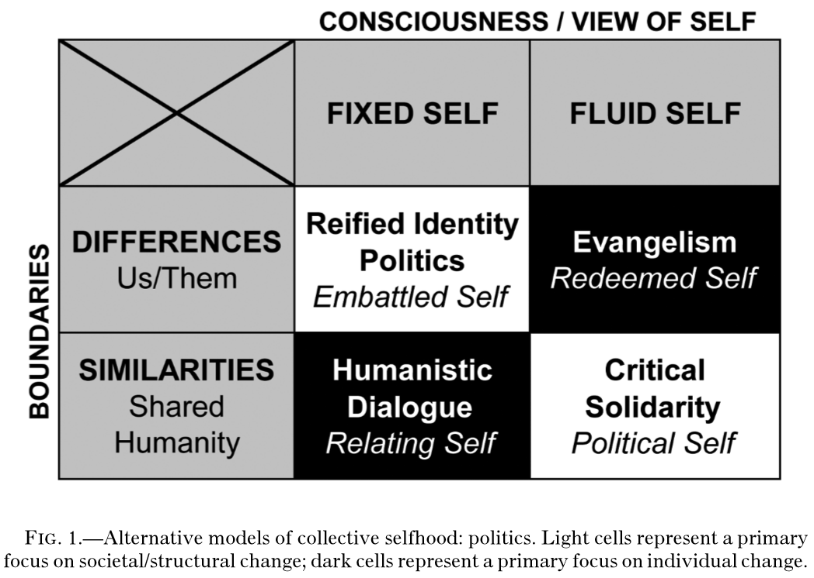 (Moon, 1345)
Though Moon does not acknowledge the dominant American Jewish narrative she references as constructed by race (white), class (middle) or gender (male), I nonetheless find the rubric she employs, Woocher’s Seven Tenets of Civil Judaism to be a useful way of understanding normative liberal Jewish groupness. This organizational value set established and developed from the 1930s to the 1980s serves as the normative narrative of today’s mainstream liberal Jewish movement. “Organizers sought to create a shared consciousness of American Jewishness in the face of multiple competing perspectives; that shared consciousness included deﬁning the boundaries of Jewishness by maintaining Jewish tradition and principles in the face of “a threatening world.” References to the threatening world, social justice, and the centrality of the state of Israel reﬂect a sense of politicization.” (Moon 1348-1349.)
Seven Tenets of Civil Judaism
- The unity of the Jewish people
- Mutual responsibility
- Jewish survival in a threatening world
- The centrality of the state of Israel
- The enduring value of Jewish tradition
- Tzedakah: Philanthropy and social justice
- Americanness as a virtue (Woocher 67-68)

These Tenets of Civil Judaism are the normative identity backdrop against which the alternative narratives, the response identity stories of organizations like Tzedek Lab and Bend the Arc, emerge. I see this emergence, the emergence with which I identify as a new anti-racism Jewish groupness in direct response to the failings of the previous movement’s capacity to adapt to cultural, ideological, and theoretical change.
Ultimately, Moon’s recognitions of the alternative narratives people use within identity politics helps us to 1. understand the multiplicity of ways people imagine ourselves as individuals, as parts of marked collectivities, and as parts of larger social systems; 2. develop more resilient and nuanced considerations of conﬂicts within social groups; and to 3. recognize the consequential importance of contestations over these deﬁnitions and their effects for social action. (Moon, 1338) In detailing the process of appearance of these alternative and emergent narratives of collective selfhood resulting from failure of group norms to reflect a meaningful worldview to its members, Moon shows us how recognizing these narratives can help us to better understand and co-create new, more meaningful movements. (Moon 1338)

On the Politics of Being Jewish in a Multiracial State
“When people come together to engage in collective political action, they also gather together to construct themselves as political agents. Part of this process involves analyzing the ways in which the particular uniting issue is important to each of them. This requires explaining the parts of one's social being or the social identities through which we make our most powerful connection to the issue. Often such connections are constructions of we-ness: racism or sexism is directed against us; homophobia hurts us, etc. However, many who participate in various movements for social justice are not part of the obvious "we." Neither scholars nor activists any longer take ethnic identity for granted as monolithic or as a natural and primordial attachment. We are becoming increasingly self-conscious about issues of identity, memory and history.” (Brodkin, 59)

In her 2003 anthropological conceptual study On the Politics of Being Jewish in a Multiracial State, Karen Brodkin addresses the main research question “What kind of Jewishness do Jews create when they pursue social justice as Jews in North America today?” (Brodkin, 59) She questions how North American Jewish activists, who she posits are mainly coming from a degreed position of class and racial privilege, construct themselves as political players when we connect to modern movements for social justice centering on the priorities of low income people of color. (Brodkin, 60) Looking at Jewish identity in the construction of Jewish justice and political activism as a communal effort, she uses the evolution of the telling of the 1911 fire in the Triangle Shirtwaist factory as an allegorical narrative which elucidates the shifting cultural narrative imaginary of liberal Jews in North America. The telling of this story, she observes, has changed greatly in the last 50 years. “Recent tellings suggest that it is performing identity work in the constitution of a progressive Jewishness, in relationship to issues of race and gender. In particular, by portraying Jewish women's identities in ways that emphasize social justice activism as Jewish, these tellings also give men a platform from which to rethink the repertoire of alternatives of Jewish masculinity embedded in the old stories.” (Brodkin, 59)
Brodkin fully embraces looking at the narrative potential of the reinvention of the fire story from a Jewish feminist intersectional lens, employing both intercategorical and intracategorical analysis, by first looking at Judaism (race, and white dominance within North American Judaism) as a category, then adding in both class and gender meanings, constructions, and positionality. Though she does not connect her analysis directly to injustice for Jews of Color, she nonetheless begins to employ a Jewish feminism that must be held accountable for critical race work for “all Jews and for all of us – Jewish and non- or not-so-Jewish.” (Brettschneider, 23) She is also solidly in line with Frankenburg’s call to understand one’s own social geography.
Brodkin posits that identity making encompasses a knowing or unknowing strategic selection of stories and images for internal and external self-explanation. She goes on to suggest that the ways members of groups construct their identities shapes the political framing of the group and impacts the direction it takes. When participants do not have a seemingly personal connection to an issue of concern, the construction of identity formation narratives creates a mutually constitutive process for the issues and actors alike. “Jews have a long history of participation in progressive social movements, but not quite often as Jews” (Brodkin, 60) which she understands as a direct enactment of Jewish otherness in North America. This Jewish vicariousness (Seidman) emerges in the context of a landscape of identity politics wherein which discourse of ethno-racial politics equates claims to oppression, and the Jewish activists who understand this (and recognize white dominance within North American Judaism as well as white assimilation in the larger North American social field) are reluctant to present their work as specifically Jewish. Brodkin then makes a case for drawing upon a “Jewish cultural heritage of collective memories – historical events, stories and images – to explain, justify, connect to or model specifically anti-racist and progressive Jewish identities.” (Brodkin 61)
Her case study of the telling of the Triangle Shirtwaist factory fire of 1911 shows how the “emphasis in the telling of this story has changed in the last several decades from one in which women are tragic victims of capitalist greed to one in which they are active fighters for social justice against that greed.” (Brodkin, 62.) She then goes on to frame this shift in telling to be primarily driven by the centrality of women telling the story. This woman’s retelling posits women as fighters against their own class, race (Jewish/white), and gender oppression, which creates a feminist bridge to other present anti-oppression struggles. This telling, then creates a counter-narrative to the previous Jewish self-conception of social justice, which was imbued with stories and virtues of Jewish masculinity (as the mainstream of Jewish assimilation offered very different arrangements to Jewish men and Jewish women) and Jewish victimhood (vis a vie the Nazi Holocaust). The feminist movement, Brodkin suggests, “opened up a conceptual and discursive space for Jewish women to critique the male dominance of post-World War II Jewishness, and from there, to rethink Jewish identity more generally.” (Brodkin 65) This work has the intersectional potential to restore the placeness of Jewish working class women in Jewish identity formation.

Social Construction of Whiteness in U.S. liberal Judaism
  - “It matters for white-passing Jews to dismantle white supremacy in bodies, communities & institutions. Ashkenazi Jews tend to root in whiteness because they (we) have been trained to, not because it's true. From where I sit, we have the responsibility to unentrain this, in ways that nuance awareness of and dismantle white supremacy, racism and anti-Semitism from our bodies, our actions, our minds and our creations, as well as the structures we live inside of.” Taya Mâ Shere

The (dis)similarities of white racial identities
“Some forms of whiteness are characterized as post-civil rights identities that ‘backlash’ against recent legal and policy advancements toward equality, while the other side of the spectrum locates forms of whiteness that actively resist racism and which are considered ‘antiracist’.” (Hughey, 1291)

In his 2010 sociological empirical study The (dis)similarities of white racial identities: the conceptual framework of ‘hegemonic whiteness’, Matthew Hughey “advances an analytic framework for the study of US-based white identity that can account for both white homogeneity and heterogeneity.” (Hughey, 1290.) This article examines the processes of white racial identity formation in the United States via an examination of a white nationalist organization and a white antiracist organization. Findings indicate that the “construction of white racial identity in both groups is based on the reproduction of various racist and essentialist ideologies. The realization that there is a shared ‘groupness’ to outwardly different white identities has the potential to destabilize the recent trend that over-emphasizes white heterogeneity at the expense of discussion of power, racism and discrimination.” (Hughey, 1289.) In his analysis, he takes into account the formation of whiteness in context of the social location of the white actor.
Hughey’s qualitative and quantitative sociological research studied two groups, a total of 45 members of each group were studied, and 93% of total participants were men. His methodology was a combination of ethnographic fieldwork, attending meetings, and semi-structured interviewing with members, content analysis of newsletters, emails, and office memos. Hughey was known to all participants as a researcher and all members consented to participating in the study.

(Hughey 1293-1294)

Hughey goes against more common notions of hegemonic whiteness when he employs 3 different identity establishment processes which contribute to white racial formation. Affective whiteness, whiteness through emotional context and response, informs identity particularly when group members did not exhibit dominant emotional performances. In these cases, they were seen not only as abnormal, but rather “their racial identity was understood as inferior and deficient.” (Hughey 1302) Conscious whiteness, establishes whiteness through exemplifying the liberal and enlightenment principles of individualism, equality, freedom, rationality, and objectivity. In these cases, racial identity was proven though an ability to “see though the ‘propaganda’ and ‘disinformation’ of society in order to adopt, willingly and without coercion” (Hughey, 1303) the racial worldview of the group. The third pattern, simplistic whiteness, expressed in the group through a valorization of simplicity wherein which racial identity formation was understood in the context of the axiom ‘the simplest explanation is always the best explanation.’
Hughey (unknowingly) employs an intersectional theoretical toolset (both elements of intracategorical and intercategorical) when he examines the multiplicity of white identity formation as both inter-racial definitions of whiteness (projected against people of color) as well as intra-racial definition of whiteness (projected against other types of whiteness.) He suggests a logic of white identity based not only on delineation between white and non-white, but also between different varieties of white. He thus not only uses intersectionality analysis, but he replicates one of the powerful outcomes of an intersectional approach, which is to disengage with binary modes of thinking and, as Nancy Lopez says “use intersectionality to resist ontological flattening.”

Problematic White Identities and a Search for Racial Justice
“What is striking in these accounts is that it's not just having the approximating experience that is important, rather it's the development of an analysis that names and critiques the links of oppression in a "white, patriarchal, economically unjust system." The activists I spoke with all talked about the importance of these experiences not only for their own development as antiracism activists but also as an effective organizing tool with other whites.” (Eichstedt, 464)

Informing Hughey’s assessment, Jennifer Eichstedt, in her 2001 sociological empirical study (which predated Hughey’s article by 9 years) “Problematic White Identities and a Search for Racial Justice” argues that the identity formation processes of self defined white antiracist activists “do not reify an essentialist construction of whiteness, but in fact work to deconstruct a singular, monolithic whiteness.” (Eichstedt, 447) Her paper explores how white antiracism activists intercede between a fixed construction of "white racism" and a more positional understanding of racism. She concludes that in the social landscape of monolithic whiteness, the activists have instituted methods to “empower themselves and to conceptualize their relationship to racism and antiracism activism in a less rigid way. All of this contributes to our understanding of the complexity of white identity and efforts to demonstrate how it is an identity that, like other identities, is always in formation.” (Eichstedt, 445)
Her qualitative method was based on exploratory research and interviews with sixteen white antiracism activists and employed two primary motivations. First, “the motivation of whites engaging in this work is not self-evident; that is, their activism needs explaining if we believe that people only engage in activism out of ‘self-interest.’” (Eichstedt, 449) Second is the environment of little or no research which positions the activists’ own analysis of the work they are doing. Eichstedt was “interested in those white people who have made a conscious decision to engage in public and collective interventions around racism” (Eichstedt, 449) and participants were contacted using a convenience/snowball method. Of the 16 people interviewed, 2 were white gay men, and 14 were white lesbians. Half of the lesbians were Jewish. Eichstedt observes that the “fact that the group of interviewees are all lesbian/gay, and half are Jewish, means that this sample cannot be considered representative of the entire white antiracism community in the United States. However, there is anecdotal evidence to suggest that women and gay men/lesbians are overrepresented in antiracism work. Even more anecdotal and research evidence suggests a Jewish overrepresentation among committed antiracism activists … (which) helps demonstrate that the ‘benefits’ of being white are not evenly distributed and … such differential experiences of and relationships to whiteness strongly impacts … who is more likely to become antiracism activists … and that the themes that are present in these activists’ narratives are echoed in writings by heterosexual and gentile white antiracism activists.” (Eichstedt, 450) Interviewees ranged in age from 24 years to 52 years old. All but four attended college and five grew up working class or economically poor. Interviewees were interviewed with assurances of confidentiality and were conducted from a standardized interview schedule, though the format was relatively dialogic.
Interestingly, Eichstedt seems to note how an instinctive unstated intersectionality can impact the way these white antiracist activists understand whiteness and racism, and find meaning-making and recruiting usefulness beyond binary, and yet the author herself does not apply direct intersectional tools as a component of her theoretical framework. Though she does employ positionality to locate herself within the work (“I engaged in these interviews as a white antiracism activist scholar; that is I identified myself as someone who participates in social activism and views my own research and activism as directly linked” (Eichstedt, 450), and she conceptually and roots her work in an intersectional understanding of power in line with both Frankenburg’s Social Geography and Collin’s Matrix of Domination. Unfortunately, she does not apply intersectional analysis to make sense of her data qualitatively. She notes, however, that antiracist white activists counter monolithic whiteness (using overlapping oppressions to access empathy – i.e. Judaism) in identity formation as white antiracists and simultaneously guard against the strategy to disavow one's white identity, which “is to miss the point of how legal, economic, political, and social systems in the United States have operated to advantage people on the grounds of being white, not on the grounds of being Polish, Irish, and so on.” (Eichstedt 454.) She offers that among her interviewees, the most shared manner for disrupting a monolithic sense of whiteness/power is for activists to understand whiteness as crosscut by other axes of oppression. She cites the example that white activists named the utility in antiracism trainings (which ideally served as recruitment for other activists) of presenting “a model of privilege and power that demonstrates that no one is ever completely an oppressor or completely oppressed.” (Eichstedt, 462) Specifically, the activists explained that though whites are part of the dominant racial group “they may also belong to a group that is subordinate in other realms-such as class, gender, or sexual orientation.” (Eichstedt, 462)
She recognizes the limitation of anticategorical intersectionality when she observes the “very activism employed by the movements destroys the standpoint on which they stand. For white antiracism activists the dilemma is a bit different. They want to deconstruct the essentialism of racism-including the solidification and reification of a static white identity. However, they insist on retaining the rhetorical and analytical piece that recognizes that dominant group members are not in an equivalent place as subordinate group members.” (Eichstedt, 466) Ultimately, she presents the organizing potential of alternative (precarious) constructions of whiteness (vis a vis Judaism) exploring the ways in which white antiracists work through the pressure of seeing themselves both as having internalized racial superiority and finding ways to see themselves as valuable contributors to the resistance and deconstruction of systemic racism. This represents a change in their conception of group position thru the work of anti-racism engagement.

Theorizing Diversity from A Jewish Perspective
“How am I to make sense of Jews and Jewish identity struggles in the United States? When I say Jews here I fully intend to connote the community of Jews in its diversity. I do not mean merely "normative" Jews; members of certain racial, class, or gender groupings. I want to explore Jews as also poor and working class people, as women, queers, secular, single, geographically, racially, culturally and politically diverse.” (Brettschneider, 1999, 17)

Marla Brettschneider writes, in her 1999 conceptual article Theorizing Diversity from a Jewish Perspective, written in her role as an associate editorial board member for the interdisciplinary intersectional journal Race, Gender, & Class “this essay will develop one sort of Jewish grounding to the discussion of the identity politics of race/ethnicity, gender, class and sexual orientation in philosophical terms.” (Brettschneider, 1999, 13)
Brettschneider’s study addresses two primary epistemological problems. First, placing “the self-understandings of non-dominant communities that, although affected by dominant currents of modern/post-modern thought, have their own particular cultural frameworks of meaning and which have long histories prior to mainstreams of Western culture informing their identities” (Brettschneider, 1999, 17) inside a relevant contemporary philosophical debate which must account for ending oppressions within the context of identity based communities while still living inside and recreating these very cultures. And secondly, how those in such communities “pursue an end to their marginalization when, regardless of their "difference" from dominant paradigms, it is the power structures and paradigms of meaning of the mainstream they must confront?” (Brettschneider, 1999, 17)
She utilizes direct intersectional analysis to position the “life experiences and visions of contemporary Jews … forged in the incredible intersection of a five thousand year old contiguous community and post 1960s multiculturalism.” (Brettschneider, 1999, 18) She explains that neither modern nor post-modern philosophy can sufficiently address what I understand as the paradox of liberal Jewish identity in the U.S. today, (the paradoxical and concurrently fully integrated contradictory identifiers as both persecuted/more in danger than others as well as chosen/better than others). For a people oriented around narratives of liberation, she wisely observes that “it is no wonder that neither liberatory option - the modern one of the universal and naturalized subject, nor the fractured and fragmented, purely deconstructed and never re-constructed model of post-moderns - seems to fit for us.” (Brettschneider, 1999, 18) She continues that for non-normative Jews, “our very existence has been predicated on the deconstruction of certain categories of Jewishness.” (Brettschneider, 1999, 18) She describes these categories as Jewish feminist and queer identities, Mizrachi and Sephardi (Jews of Color) challenges to Ashkenazi (white) hegemony, and working class ideas and the actions of economic justice taken as their result. She continues that these processes “have only been possible in the fracturing of the idea of the unitary authoritative Jew. These identity constellations have been given life in a Jewishness bursting into multiplicity.” (Brettschneider, 1999, 18)
Brettschneider concludes with a persuasive and compelling civic call to duty. Her call resounds that a Jewish perspective on the identity politics of race, class, gender and sexual orientation helps us to “locate certain important components of a new democratic theory.” (Brettschneider, 1999, 21) Her call, is particularly relevant in our time of the contested structure of our so-called American democracy, in the context of the recent shooting at the Jewish Synagogue in San Diego which is understood as a part of a violent white nationalist movement that seeks to preserve and create a white ethno-state, in the landscape of the mainstreaming of this white nationalist movement and popular support for concepts like M.A.G.A., militaristic border control (xenophobia), Islamophobia and the Muslim bam, and increased restriction on reproductive healthcare. Her call is imperatively important to be comprehended by liberal Jews, who see ourselves as people who value justice, ethical action, and liberatory practice. Wouldn’t we be natural allies to countering white supremacy culture in all its forms? Instead, I see many mainstream Jewish liberal organizations doing what I interpret as reinvesting more deeply in white supremacy culture in the face of fear (increased synagogue policing) – which does not make Jews (or anyone) more safe, and in fact make Jews of Color less safe. She observes that though there have been many philosophies which have been called democratic, “none has taken the "who" question seriously enough. The political vision emerging from many Jews and those with whom they stand in solidarity challenges democrats to ask: "who" is our theory and practice serving?” (Brettschneider, 1999, 21)

Jewish Feminist Intersectionality & Anti-racism education Policy in the liberal U.S. Jewish community

  - “Yet the very fluidity that has allowed forces to buffet me from one race to anther has made it clear that my self-interest lies not in a desperate investment in whiteness, but in alliances that challenge hierarchies of race, class, sex, and gender.” Judith Ezekiel

The current policy for antiracism education in the liberal Jewish community, is understood de facto, as there currently exists no policy on antiracism education. The proposed outcome of this continuation of the status quo is an ever more segregated Jewish community (both internally segregated and externally isolated) at increased risk in a multiplicity of ways to growing political xenophobia.
I propose two potential policy recommendations. In the first, liberal Jewish institutions implement “diversity” training to attune members to language and general concepts of multiracial difference within the Jewish community. Though this would be a possible step in a superficially encouraging direction, it would not ultimately address the color-blind nature of racism within liberal Jewish communities, nor would it create potential for meaningful Jewish engagement with the dismantling of systemic oppression as it would not support individuals’ ability to self-implicate ourselves within the systems of oppression. This first policy would fall short by asking/addressing only one question, and not engaging with the co-creation and simultaneity of systemic oppression. In my second policy recommendation, I propose the adoption of a committed, long-term values-based intersectional antiracism education plan in liberal Jewish institutions which would both serve to address white hegemony within Jewish intuitions, as well as position liberal Jews to be effective accomplices to the radical movement building of collective liberation which improves life outcomes for all people subject to white supremacy culture in the U.S.
In her 2010 Political Science/Women’s Studies conceptual article, Critical Attention to Race: Race Segregation and Jewish Feminism, Brettschneider clearly defines for us, then, the components and necessity of an intersectional Jewish feminist lens and provides a values-based rubric for organizing a current move towards relevant anti-racist education in the liberal Jewish community of the U.S. According to her prescription, and in direct response to the status quo organizing methodology of Woocher’s 7 Tenants of Civil Judaism, there are 5 critical arenas of import for intersectional Jewish feminism which she roots not only in academic, and cultural critical analysis, but also in her positionality as the white mother of African American daughters. “1) We are sentencing my daughters and all Jews of color to Jewish death. Racism is murderous … If it cannot speak to my daughters’ and others’ explicitly raced experiences then we do not have enough to offer and we are allowing and are complicit in their daily death . . . Jewish and otherwise. 2) Significant parts of Jewish discourse operates through obsessions with stock components of patriarchy such as bloodlines and birthrights, and not just sex but also heterosexual sex … These are always also race issues. If we care about patriarchy and heterosexism, we have got to get on with an antiracist project. 3) Jewish feminism ought to be able to speak to important issues—and racism is one. If we don’t have critical race analyses then we have more work to do to develop them (as well as the internal anti-racism work it will take to unpack why we don’t). 4) Plenty of Jewish feminists and Jewish women are people of color … Jewish feminism created without Jewish women and feminists of color cannot inform and transform the general Jewish feminist project. 5) If we think that everyone needs to deal with their racism … and that work will need, and be enhanced by, a feminist analysis, then all Jews are in need of anti-racist analysis, Jewish anti-racist analysis, and specifically a Jewish feminist anti-racist analysis.” (Brettschneider, 2010, 30-31)
This code of belief is particularly useful to the first component of my policy brief, the claim that in order to face and dismantle the in-group racism perpetrated on Jews of Color within Jewish communities, adult education must be prioritized for racially privileged Jews to understand their racialized social location of power within the Jewish community. However, the research, so far, is lacking to substantiate my second claim that the current social justice ethic does not reflect a truly multilateral intersectional understanding of systemic oppression in the United States. It would be useful to also have an intercategorical empirical intersectionality analysis that places Jews, and Jews of Color within a larger United States context. Jewish whiteness in the U.S., primarily in terms of the themes and identity informants of self-determination, immigration, assimilation, and ambivalence, creates what Brodkin calls a kind of “double vision.” With particular regards to the theme of self-determination of the whiteness of Jews, all of the scholars engage to some degree what Nancy Lopez calls street race (how others see us) and racial identity (how we see ourselves.) Without this distinction (which is absent in the current policy status quo) there is a severe limitation on the complexity of the conversations of self-determination/identity formation, and overlooking one of the significant modes of enforcement in our highly racialized society. Brettschneider’s rubric and analysis help clarify the outmoded status quo narrative of Jewishness and thus becomes the intersectional terms of the policy recommendation for both why we need adult antiracism education in liberal Jewish spaces, as well as how an anti-racist consciousness shift can both support and improve quality of life outcomes for Jews of Color within our liberal Jewish institutions, People of Color beyond our institutions, and all those harmed by white supremacy culture and the growing white nationalist social movement.

  - “Each of us is called upon to take a stand. So in these days ahead, as we examine ourselves and each other, our works, our fears, our differences, our sisterhood and our survivals, I urge you to tackle what is most difficult for us all, self-scrutiny of our complacencies, the idea that since each of us believes she in on the side of right, she need not examine her position.”
  - Audre Lorde “Sisterhood and Survival” Keynote Address, conference on the Black Woman Writer and the Diaspora, Michigan State University, 1985

References

Baca Zinn, Maxine and Bonnie Thorton Dill. “Difference and Domination.” Women of Color in the U.S. Philadelphia: Temple University Press, 1994: 3-12.

Brettschneider , Marla. “Critical Attention to Race: Race Segregation and Jewish Feminism.” Bridges, Vol. 15, No. 2 (Autumn 2010): 20-33. https://www.jstor.org/stable/10.2979/bri.2010.15.2.20

Brettschneider , Marla. “Theorizing Diversity from a Jewish Perspective.” Race, Gender & Class, Vol. 6, No. 4, Race, Gender & Class: American Jewish Perspectives (1999): 13-23. https://www.jstor.org/stable/41674907

Brodkin, Karen. How Jews Became White Folks and What That Says about Race in America. New Brunswick: Rutgers University Press, 1994.

Brodkin, Karen. “On the Politics of Being Jewish in a Multiracial State.” Anthropologica, Vol. 45, No. 1 (2003): 59-68. https://www.jstor.org/stable/25606112

Crenshaw, Kimberle, “Mapping the Margins: Intersectionality, Identity Politics, and Violence against Women of Color.” Stanford Law Review, Vol 43, No. 6 (1991): 1241-1299.

Collins, Patricia Hill. Black Feminist Thought: Knowledge, Consciousness, and the Politics of Empowerment. Third Edition. New York: Routledge. 2009

Collins, Patricia Hill. “Toward a New Vision: Race, Class, and Gender as Categories of Analysis and Connection.” Race, Gender, and Class: Theory and Methods of Analysis, Bart Landry, editor, New Jersey: Pearson. 2007: 45-62.

Eichstedt, Jennifer. “Problematic White Identities and a Search for Racial Justice.” Sociological Forum, Vol 16, No. 3 (Sept 2001): 445-470. https://www.jstor.org/stable/684720.

Ezekiel, Judith. “I Grew Up White: Crossing Borders and Changing Race.” Meridians, Vol. 10, No. 2 (2010): pp. 124-140. https://www.jstor.org/stable/10.2979/meridians.2010.10.2.124

Frankenburg, Ruth White women, race matters: The social construction of whiteness. Minneapolis: University of Minnesota Press, 1993.

Goldstein, Eric. The Price of Whiteness: Jews, Race, and American Identity. Princeton: Princeton University Press, 2006.

Heschel, Susannah. “The Slippery Yet Tenacious Nature of Racism: New Developments in Critical Race Theory and Their Implications for the Study of Religion and Ethics.” Journal of the Society of Christian Ethics, Vol. 35, No. 1 (Spring / Summer 2015): 3-27. https://www.jstor.org/stable/24615154

Hughey, Matthew. “The (dis)similarities of white racial identities: the conceptual framework of ‘hegemonic whiteness’.” Ethnic and Racial Studies, Vol. 33 No. 8 (2010): 1289-1309

Kaye/Kantrowitz, Melanie. The Colors of Jews: Racial Politics and Radical Diasporism. Bloomington: Indiana University Press, 2007.
López, Nancy. “Contextualizing Lived Race-Gender and the Racialized Gendered Social Determinants of Health, Mapping "Race." Critical Approaches to Health Disparities Research, Laura Gómez and Nancy López, editors, Piscataway, NJ; Rutgers University Press, 2016.
McCall, Leslie. “The complexity of intersectionality.” Signs, No. 30 Vol 3 (2005): 1771-1800. http://jstor.org/stable/10.1086/426800
Moon, Dawne. “Who Am I and Who Are We? Conflicting Narratives of Collective Selfhood in Stigmatized Groups.” American Journal of Sociology, Vol. 117, No. 5 (March 2012): 1336-79. https://www.jstor.org/stable/10.1086/663327

Rose, Dawn Robinson. “Class as Problematic in Jewish Feminist Theology.” Race, Gender & Class, Vol. 6, No. 4, Race, Gender & Class: American Jewish Perspectives (1999): 125-135. https://www.jstor.org/stable/4167491

Rosenwasser, Penny. Hope into Practice: Jewish Women Choosing Justice Despite our Fears. Penny Rosenwasser, 2013.

Rosenwasser, Penny and Anna Gatmon. “Crosscurrents of Jewish Women in a Journey Towards Healing.” Bridges, Vol. 8, No. 1/2, Confronting Text and Tradition (Spring, 2000): 116-123. https://www.jstor.org/stable/40358560

Seidman, Naomi. “Fag-Hags and Bu-Jews: Toward a (Jewish) Politics of Vicarious Identity.” Insider/Outsider: American Jews and Multiculturalism, David Biale, Michael Galchinsky and Suzannah Heschel (eds.), Berkeley: University of California Press, 1998.

Weber, Lynn. Understanding Race, Class, Gender and Sexuality: A Conceptual Framework. Second Edition. Oxford: Oxford University Press. 2010

Woocher, Jonathan S. Sacred Survival: The Civil Religion of American Jews. Bloomington: Indiana University Press. 1986.

